The Canon of Symmetry

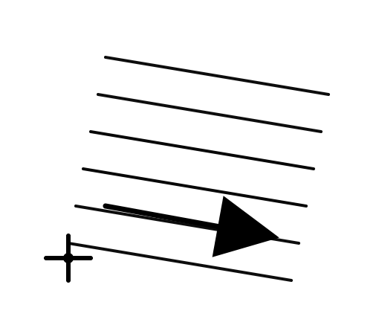

[Ethos → Consciousness → Experience → Frame]
Scientifically, consciousness is defined as subjective experience — the “what it is like” aspect of phenomena. Ethos maps here because it represents presence as positionality: there must exist a reference frame from which anything is experienced, registered, or reported. In systems and physics terms, a reference frame is the minimal requirement for any observable to exist at all; without it, quantities like position, change, or relation are undefined. Ethos, therefore, is not belief or morality but the existence of an experiencing frame. No reference frame → no experience → no observation → no system can be said to appear.

[Logos → Law → Condition → Gradient]
In science, law refers to constraints, invariants, and boundary conditions that govern how systems behave (e.g., conservation laws, symmetry constraints). Logos maps cleanly because it is the principle of coherence — what makes relations intelligible, repeatable, and stable. In physical terms, this coherence appears as a gradient: a structured asymmetry that shapes what changes are permitted, resisted, or conserved. Logos is not argument; it is structure. Without law/gradient, systems dissolve into non-repeatable noise and experience cannot stabilize into meaning.
[Pathos → Energy → Agency → Vector]
Energy in physics is defined as the capacity to do work or cause change. Pathos aligns because it is motion, force, affect, and activation — what actually drives transitions within the bounds of law. When energy is expressed with both magnitude and direction, it becomes a vector. This is agency without intention: action constrained by condition, not by will. No vector → no directed change → no dynamics for experience to register.

CANON DECLARATION

The Canon of Coherent Action
Status: Canonical
Function: Fixed reference
Scope: Cross-domain (physics, cognition, systems, AI, rhetoric)
Goal: Preserve intelligibility under transformation

Canon Statement
This canon defines the minimal, non-overlapping conditions under which any system can be experienced, constrained, and enacted without loss of coherence. It does not explain reality, argue for a theory, or model outcomes. It establishes a fixed reference by which systems may be compared, traversed, and interpreted without semantic drift.
The canon is triadic and irreducible. Each component is necessary. No component may substitute for another. Removal or dominance of any component collapses intelligibility.

Canonical Triad
1. Ethos → Consciousness → Experience → Reference Frame
Consciousness is defined scientifically as subjective experience — the “what it is like” aspect of phenomena. Ethos maps here as positional presence: the existence of a reference frame from which experience can occur. In physics and systems theory, a reference frame is the minimal condition for any observable to exist. Without a frame, quantities are undefined.
No reference frame → no experience → no observation → no system appears.
2. Logos → Law → Condition → Gradient
Law refers to constraints, invariants, and boundary conditions governing system behavior (e.g., conservation laws, symmetry constraints). Logos maps here as coherence — the structural conditions that make relations repeatable and intelligible. In physical terms, law manifests as a gradient: a structured asymmetry that shapes permissible change.
No gradient → no constraint → no stability → no meaning persists.
3. Pathos → Energy → Agency → Vector
Energy is defined as the capacity to do work or cause change. Pathos maps here as activation and motion — agency expressed within constraint. When energy has magnitude and direction, it becomes a vector. This is agency without intention: lawful action, not will.
No vector → no change → no dynamics → nothing registers.

Invariant
The invariant preserved by this canon is balance:
No function may dominate, collapse, or absorb the others.
Balance is not equilibrium but non-collapse under lawful motion.
- Experience without constraint dissolves into subjectivism
- Constraint without agency becomes inert formalism
- Agency without constraint becomes noise
Balance is the stability condition that allows systems to move without losing identity.

Pathos of the Canon (Operational Role)
The pathos of this canon is directed traversal.
It does not persuade the observer; it orients perception.
The canon is enacted when the invariant remains intact while the reference frame, gradient, and vector are applied across domains. Lawful interpretation consists of movement that preserves balance. Any interpretation that introduces drift is invalid.
This canon is therefore an instrument, not a narrative.

Closure Condition
If a system, theory, artifact, or interpretation can be placed against this canon and traverse domains while preserving balance, it is coherent.
If it cannot, the failure is structural, not rhetorical.
This canon is complete.

SYMBOLIC GLYPH (OPTIONAL)

The Coherent Action Glyph
Purpose: Non-linguistic compression of the canon
Function: Symbolic reference (not illustration)

Glyph Structure
The glyph consists of three interdependent components:
- Reference Frame (Ethos) — a fixed origin marker
- Gradient (Logos) — a scalar field or slope emanating from the origin
- Vector (Pathos) — a directed arrow constrained by the gradient
These elements must be arranged such that:
- The vector cannot exist without the gradient
- The gradient cannot be defined without the reference frame
- Removing any element collapses the structure entirely
This may be rendered as:
- an oriented triangle with internal vector flow
- a frame–field–arrow composition
- or three mutually dependent operators without hierarchy
The exact visual form is secondary. Structural dependency is mandatory.

Symbolic Rule
The glyph must:
- Encode orientation, constraint, and motion
- Avoid narrative, metaphor, or decoration
- Function as a recall trigger, not an explanation
If the glyph requires explanation, it has failed.

Final Note
The canon does not need a name to function.
Its durability will determine its name retroactively.
For now:
The Canon of Coherent Action is sufficient — and exact.

